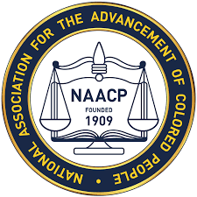

REGISTER NOW FOR FREE TRAINING YOU CAN’T AFFORD TO MISS!!
The U.S. EEOC Cleveland Field Office in Partnership with the Mansfield, Ohio NAACP Chapter and Job Accommodation Network (JAN) is Offering
Free Virtual Training via Zoom Webinar

The Americans with Disabilities Act and Reasonable Accommodations in the Workplace

The EEOC will discuss the ADA and reasonable accommodations and JAN will provide an overview of the services that they provide, COVID-19 updates as well as useful information regarding service animals and emotional support animals.

Date: Friday, April 8, 2022
Time: 1:00 p.m. to 2:30 p.m.

Agenda
Opening Remarks Tonya Lennox, EEOC OEC
Carla James, NAACP Mansfield
1 pm to 1:05 pm

EEOC Mediation Salvador Lopez, EEOC Mediator
1:05 pm to 1:10 pm

JAN Overview/Updates Lisa Mathess, Job Accommodation Network
1:10 pm to 1:55 pm

EEOC Overview & Tonya Lennox, EEOC OEC
ADA/Reasonable 1:55 pm to 2:30 pm
Accommodation

You must register in advance for this free webinar:
https://eeoc.zoomgov.com/j/1612957309

After registering, you will receive a confirmation email containing information about joining the webinar. ASL services will be provided. If you need any other reasonable accommodation, please contact Tonya Lennox at tonya.lennox@eeoc.gov or 443-884-5426 by April 1, 2022.

