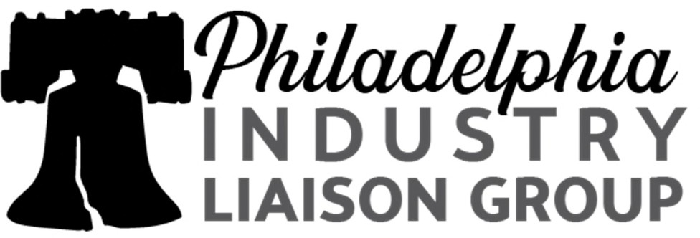

Quarterly Meeting
Thursday, May 19, 2022
11:00 am – 2:00 pm

Agenda

11:00am – 11:10am Opening Remarks
Philadelphia ILG - Allison Fantine, Chair & Tracey Hamilton, Vice Chair
NILG Update – Ornella Castman, Chair of the Mid-Atlantic ILG

11:10am – 12:00pm Veteran-Focused Panel Discussion

Topic: Supporting Veterans in Today's Workforce while meeting your requirements as a Federal Contractor

Moderator; Tracey Hamilton

Panel of Experts:
- Agency Representation:
- OFCCP; Edward Rogers District Director

- Federal Contractor Representation:
- Comcast; Edward Carr Military/Veteran Affairs

- Veteran Panel Participants:
- AliroVets ; Jonathan Fermin-Robbins
- Buffer Springs; Rob Arndt
- Evocati LLP; Barrett Bogue
- InvestVets; Michael Poyma
- RecruitMilitary; Chris Newsome

12:00pm – 12:45pm OFCCP General Update

Edward J. Rogers, OFCCP Philadelphia District Director

Sam Maiden, Regional Director for the Mid-Atlantic Region

12:45pm – 1:15pm EEOC General Update/Hot Topics

Tonya Lennox, Outreach & Education Coordinator

1:15pm – 2:00pm OFCCP Planned Regulatory Agenda

Matt Camardella, Principal Jackson Lewis P.C.

Note to Members/Attendees
--We look forward to providing informative sessions to enhance you as professionals in the world of equal opportunity.
--Next Quarterly Meeting: August 18, 2022

The Philadelphia Liberty Industry Liaison Group (Liberty ILG) is a regional professional organization in the Philadelphia, Pennsylvania area established under the guidance of the National Industry Liaison Group (NILG). Its primary purpose is to develop positive partnerships between industry and the Office of Federal Contract Compliance Programs (OFCCP) of the U.S. Department of Labor. Liberty ILG liaises with OFCCP, the U.S. Equal Employment Opportunity Commission (EEOC) and other fair employment practice agencies to further affirmative action and diversity goals and to support strategic business objectives.

Tour our web site and visit our LinkedIn group for details on Liberty ILG, its geographic scope, and general meetings, and to consider joining ILG to actively address important issues and reach mutual goals.

