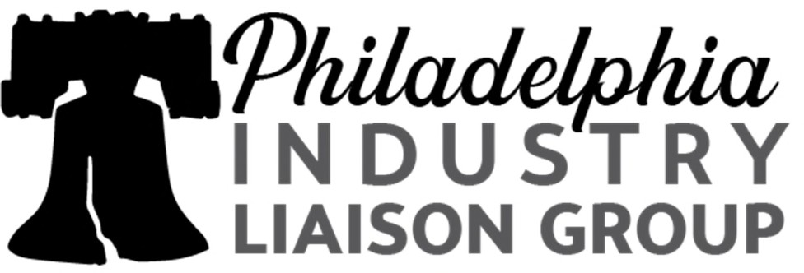

Quarterly Meeting
Thursday, November 17, 2022
11:00 am – 2:00 pm

Agenda

11:00am – 11:15am Opening Remarks & Chapter Business
Philadelphia ILG – Allison Fantine, Chair, Tracey Hamilton, Vice Chair, and Jo Bennett, Treasurer

11:15am – 11:20am Greetings from National ILG
Ornella Castman, Chair of the Mid-Atlantic ILG

11:20pm – 11:40pm OFCCP Section 503, District/Regional Priorities Fiscal 2023, Updates

Edward J. Rogers, OFCCP Philadelphia District Director

Sam Maiden, Regional Director for the Mid-Atlantic Region

11:40pm – 12:00pm EEOC General Update/Hot Topics

Tonya Lennox, Outreach & Education Coordinator

12:00pm – 1:00pm Digital Accessibility: In the News and In Your Workplaces

Matt Camardella, Jackson Lewis and Janet Fiore & Mike Mangos, The Sierra Group

1:00pm – 2:00pm Jackson Lewis – Legal Updates

Matt Camardella, Principal Jackson Lewis P.C.

Note to Members/Attendees
Quarterly 2023 (3rd Thursday) Tentative meeting dates:
Q1: Feb, 16th
Q2: May 18th
Q3: Aug. 17th
Q4: Nov. 16th

The Philadelphia Liberty Industry Liaison Group (Liberty ILG) is a regional professional organization in the Philadelphia, Pennsylvania area established under the guidance of the National Industry Liaison Group (NILG). Its primary purpose is to develop positive partnerships between industry and the Office of Federal Contract Compliance Programs (OFCCP) of the U.S. Department of Labor. Liberty ILG liaises with OFCCP, the U.S. Equal Employment Opportunity Commission (EEOC) and other fair employment practice agencies to further affirmative action and diversity goals and to support strategic business objectives.

Tour our web site and visit our LinkedIn group for details on Liberty ILG, its geographic scope, and general meetings, and to consider joining ILG to actively address important issues and reach mutual goals.

